5.1A Determining the Limit of a Sequence

<https://www.allmath.com/limit-calculator.php>

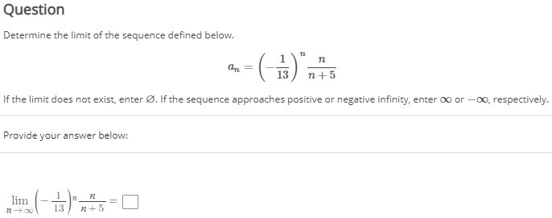

5.1B Determining the Convergence of a Sequence

<https://www.allmath.com/limit-calculator.php>

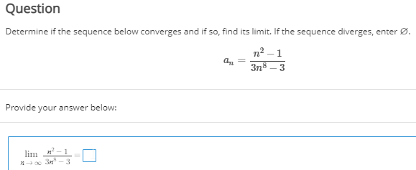

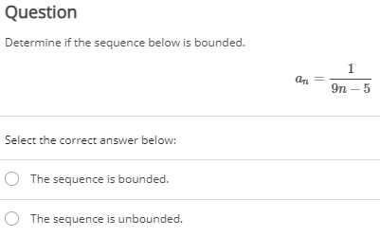

5.2A Partial Sums Geometric Series

Summation calc.

<https://www.symbolab.com/solver/series-calculator/%5Csum_%7Bn%3D0%7D%5E%7B%5Cinfty%7D%20>

Summation Series Convergence Calc.

<https://www.emathhelp.net/calculators/calculus-2/series-calculator/?f=-14sin%5En%2810%29&var=&a=1&b=inf>

5.2B Telescoping Series

<https://www.symbolab.com/solver/series-calculator/%5Csum_%7Bn%3D1%7D%5E%7B%5Cinfty%7D%20%5Cleft(%5Cfrac%7B5%7D%7B%5Csqrt%7Bn%2B7%7D%7D-%5Cfrac%7B5%7D%7B%5Csqrt%7Bn%2B8%7D%7D%5Cright)>

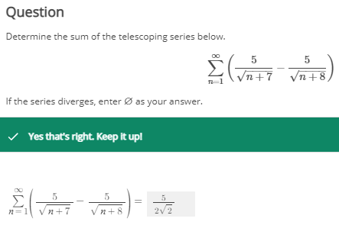

5.3A Divergence and Integral Tests

<https://www.symbolab.com/solver/limit-calculator/%5Clim_%7Bx%5Cto%5Cinfty%7D%5Cleft(tan%5E%7B-1%7D%5Cleft(n-7%5Cright)%5Cright)>

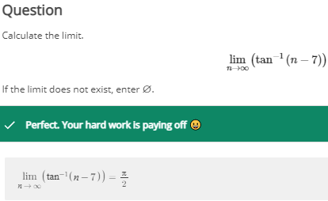

5.3B p-Series and Estimating Values of Series

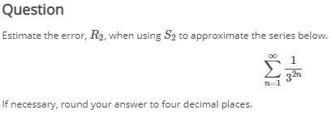

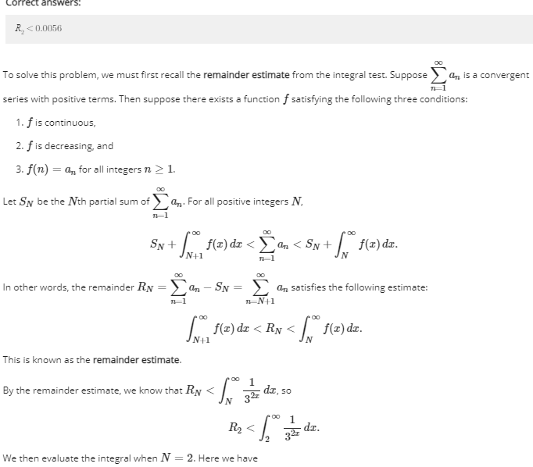

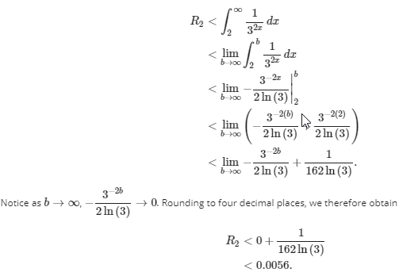

5.4 Comparison Tests

<https://www.symbolab.com/solver/limit-calculator/%5Clim_%7Bn%5Cto%5Cinfty%7D%5Cleft(%5Cfrac%7B%5Cleft(%5Cfrac%7B6%5Csqrt%7Bn%7D%7D%7B%5Cleft(n%5E%7B5%7D%2B9%5Cright)%7D%5Cright)%7D%7B%5Cfrac%7B1%7D%7Bn%5E%7B%5Cfrac%7B9%7D%7B2%7D%7D%7D%7D%5Cright)>

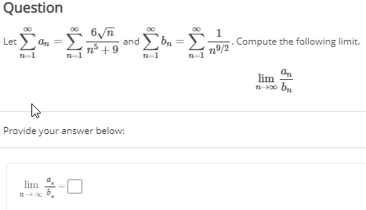

a_n is the original function.

b_n is, cut out the garbage and leave only the highest power terms that will effect the limit.

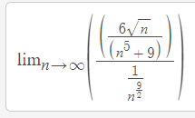 = 6

5.5A Absolute Convergence and Conditional Convergence

5.5B Alternating Series

5.6A Ratio and Root Tests

5.6B Determining Appropriate Tests for Series

**Test Rules:**

**Monotone Convergence Theorem**

It is always increasing and upper bounded, or always decreasing and lower bounded.

**Divergence Test**



**Integral Test**

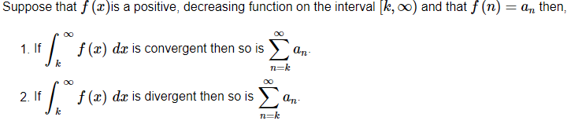

**Comparison Test**

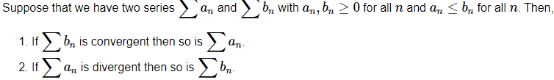

**Limit Comparison test**

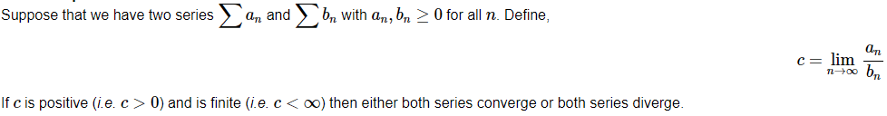

**Alternating Series Test**

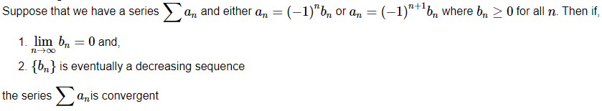

**Ration Test**

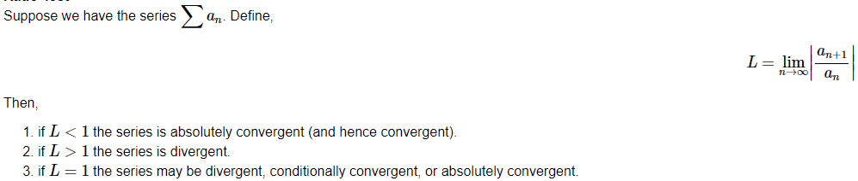

**Root Test**

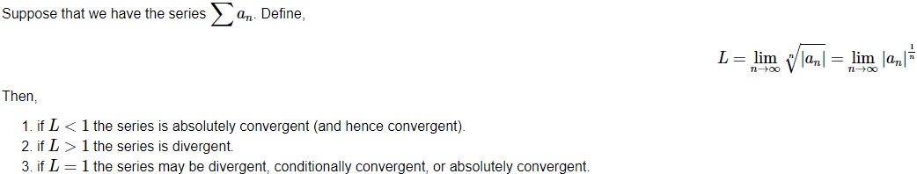

**P-Series Test**



If p > 1 Converges

If p < 1 Diverges

**Geometric Series Test**

If the ration r is less than 1 the series converges otherwise it diverges. r is what you would multiply one output by to get the next and so on.

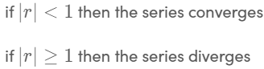

**Partial Sum**



**Sum of Series Calc./ Infinite Series Calc.**

[**https://byjus.com/infinite-series-calculator/**](https://byjus.com/infinite-series-calculator/)